Install and Setup Java JDK

1. Check your system if Java 1.8 or higher is already installed and setup. Run Command Prompt, key in java -version then hit enter. If its already installed in your system it should display the Java version information.

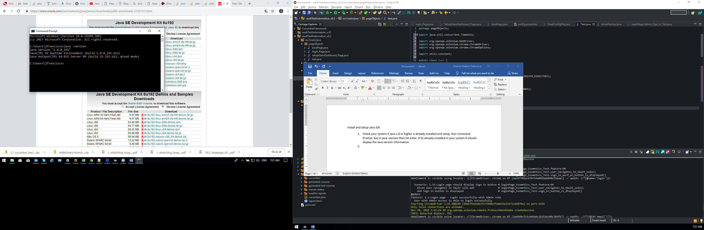

1. If your system did not display the Java details, download the JDK from this link - <https://www.oracle.com/technetwork/java/javase/downloads/jdk8-downloads-2133151.html> click Accept and download the file applicable to your system. Run the installer until it complete.

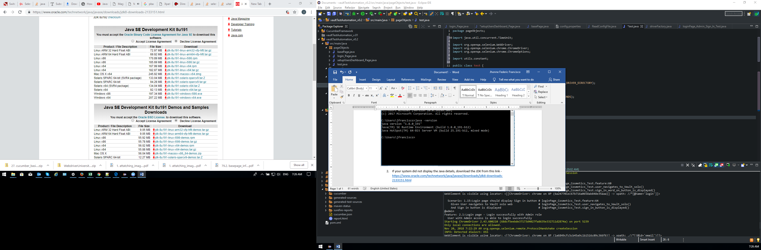

1. After installation of JDK, Locate jdk 1.8.0_191, then copy the file location of the folder. ie., “C:\Program Files\Java\jdk1.8.0_191”

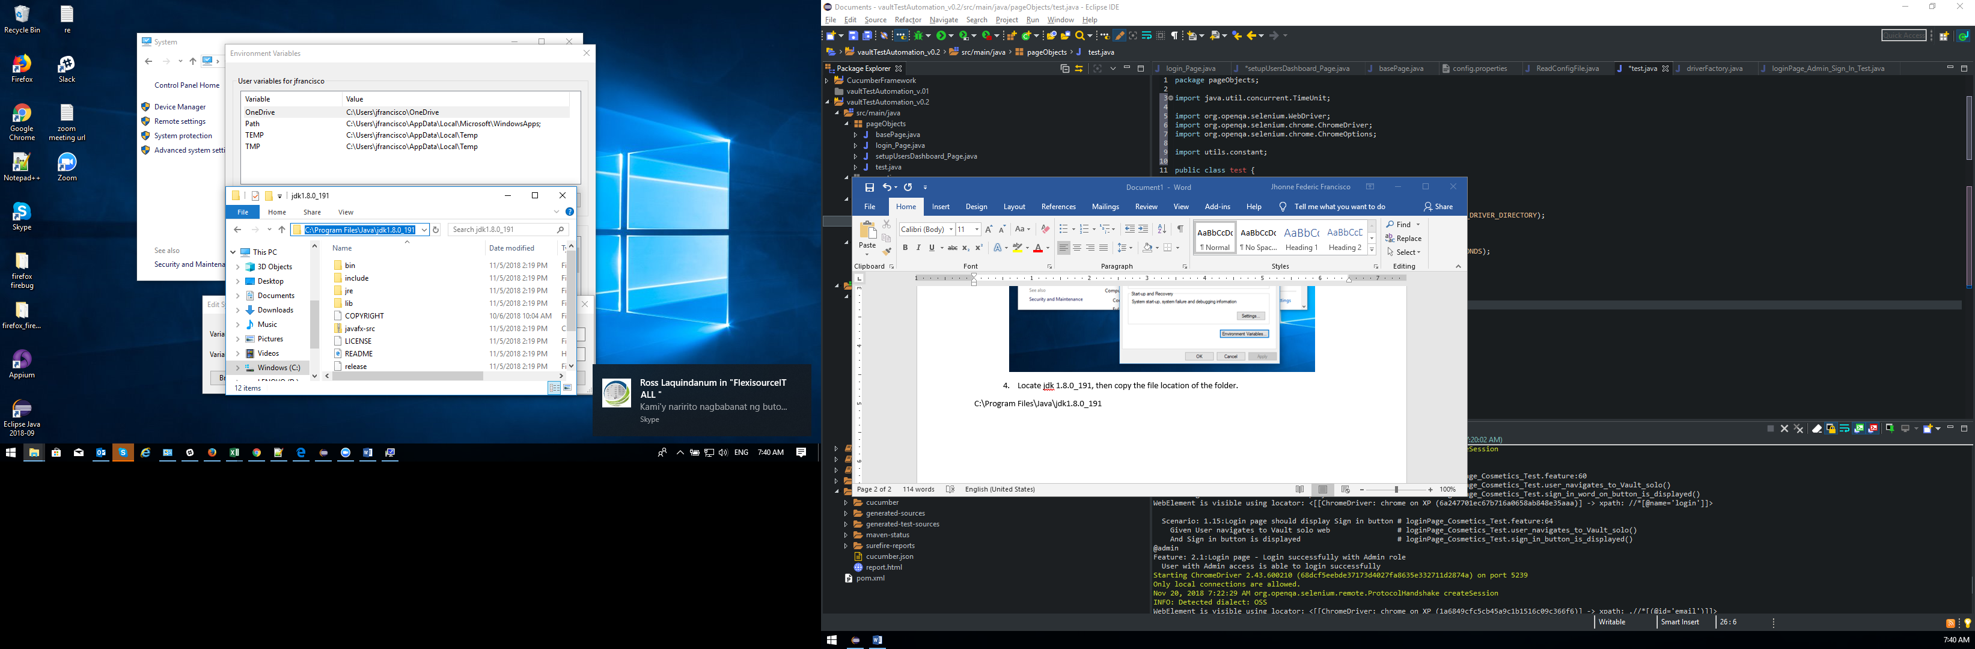

1. Setup your environment variables. Go to your Control Panel > System and Security > System > Environment Variables.

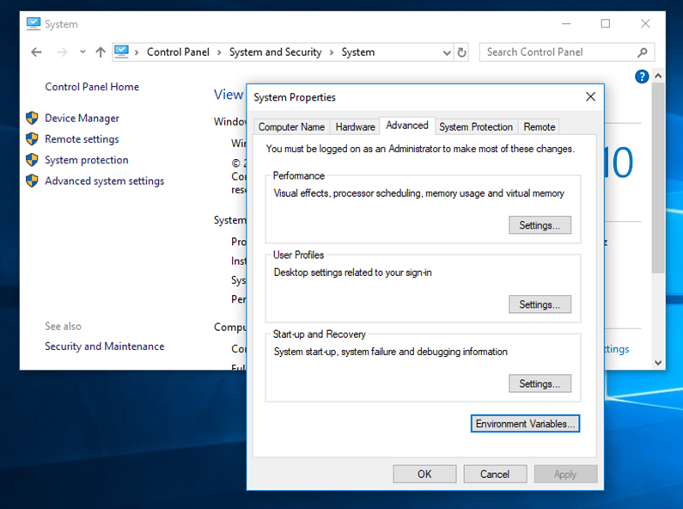

1. In the System variables, create a variable name JAVA_HOME and set the value of the java folder.

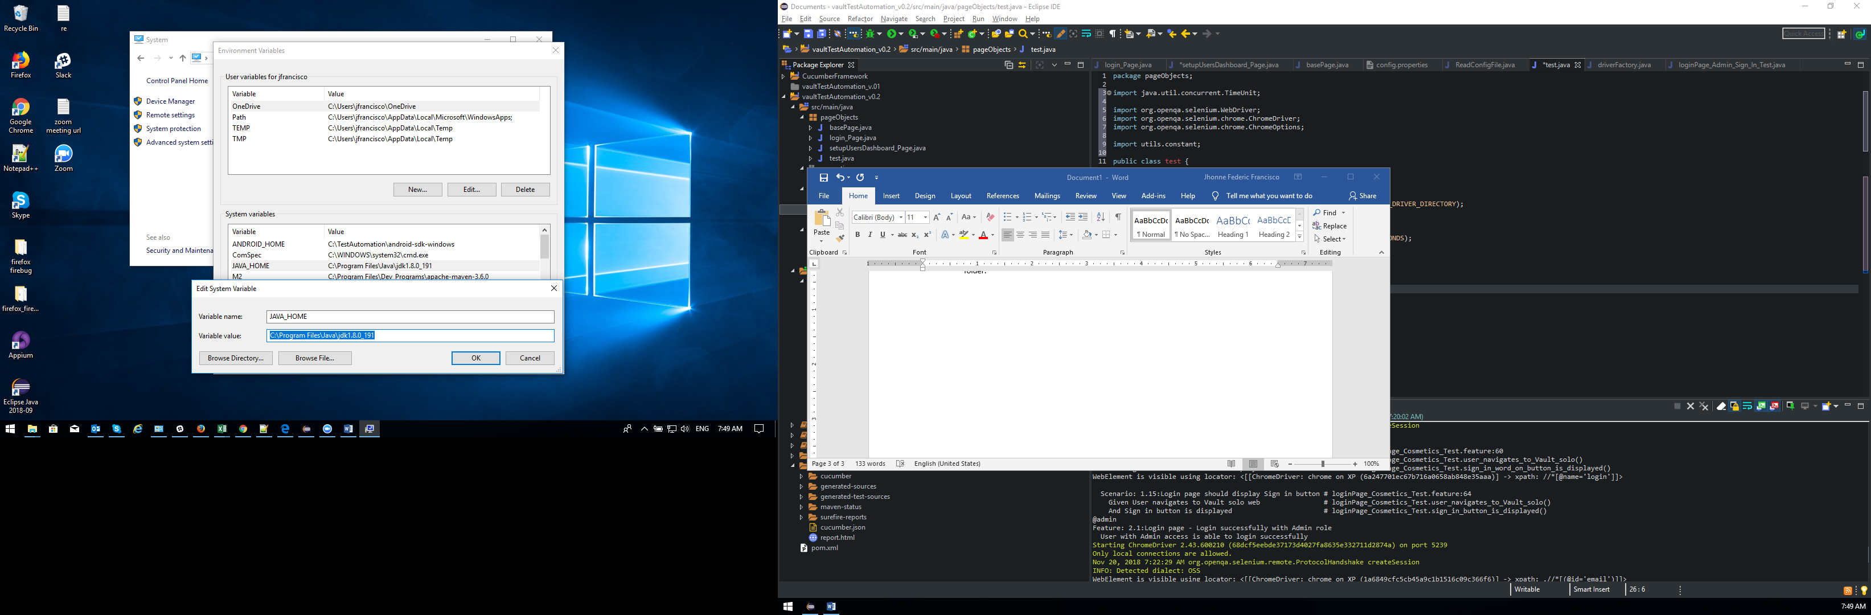

1. Then select Path and click Ed it. Click New and enter %JAVA_HOME%\bin then click OK. 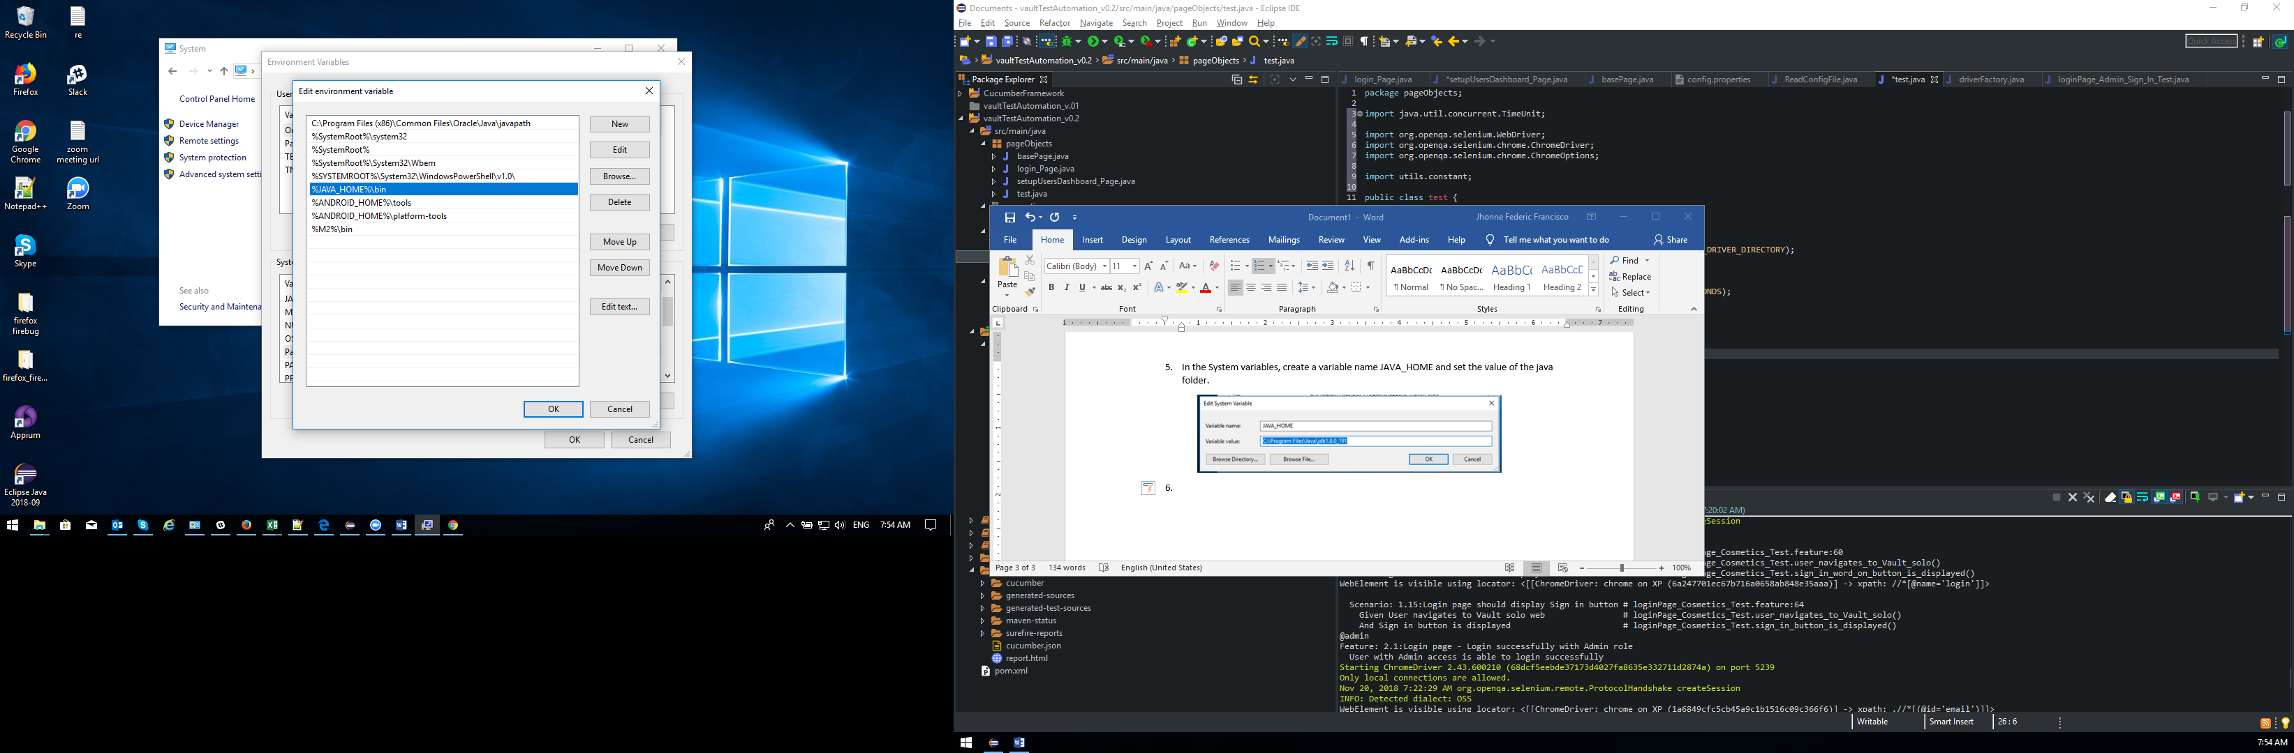
2. Open CMD again and enter java -version. Now it should display the jdk details.



Setting up Maven

1. Go to <https://maven.apache.org/> and download Binary zip archive

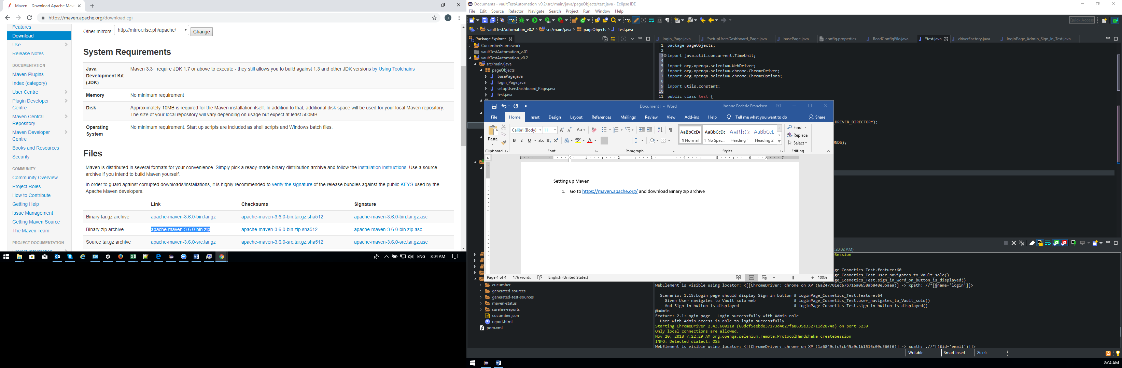

1. After it completes, create a folder under “C:\Program Files” and named it Dev_Programs. Extract the files to the folder located created in Program Files.

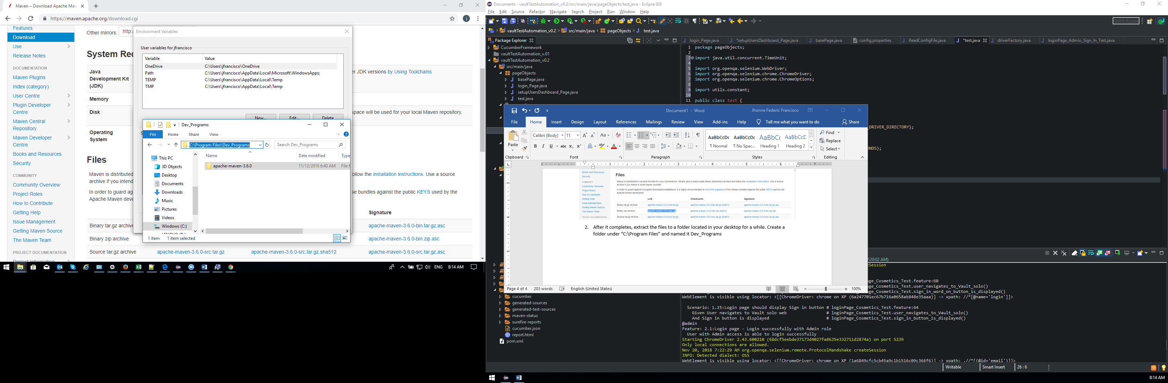

1. Go to System variables, click New and name it M2 add the location of the folder of the apache maven in the value.

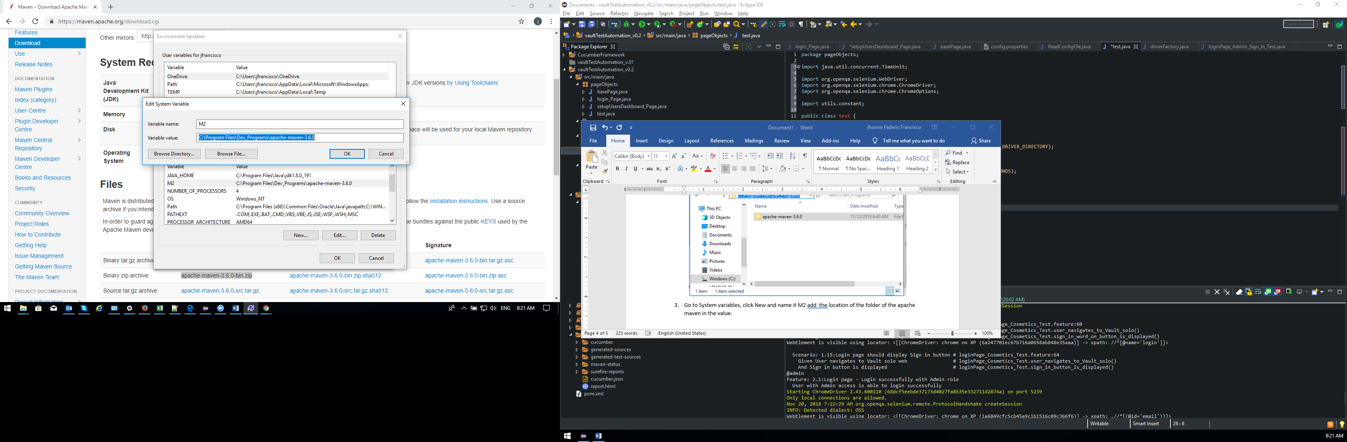

1. Then select Path and click Edit. Click New add %M2%\bin click OK, then Ok and close environment variables.

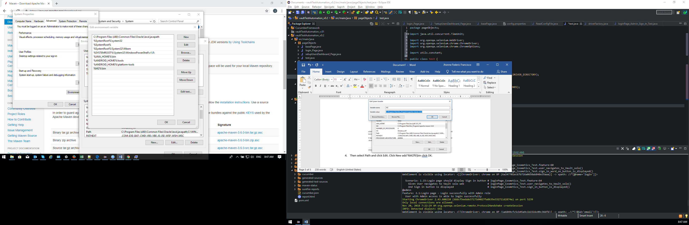

1. Open command prompt, and enter mvn -v, if the path declared was correct it will display the maven details.

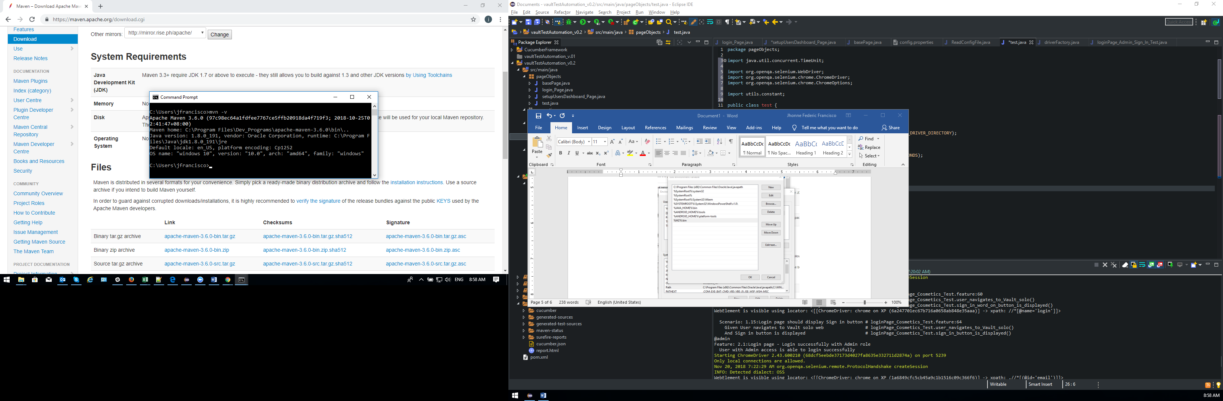

Install and Setup eclipse

1. Go to eclipse.org <https://www.eclipse.org/downloads/> click download 64 bit.

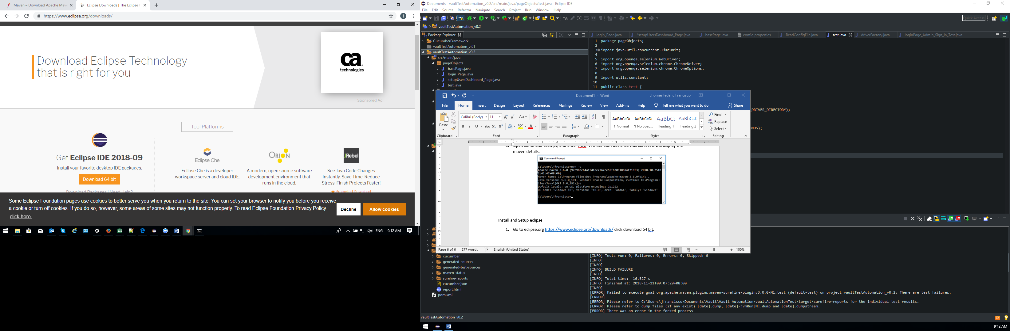

1. Follow the installation process until it completes.
2. Run Eclipse set the workspace in any location where you can easily access the folder outside eclipse.
3. In Eclipse menu click File > New > Other

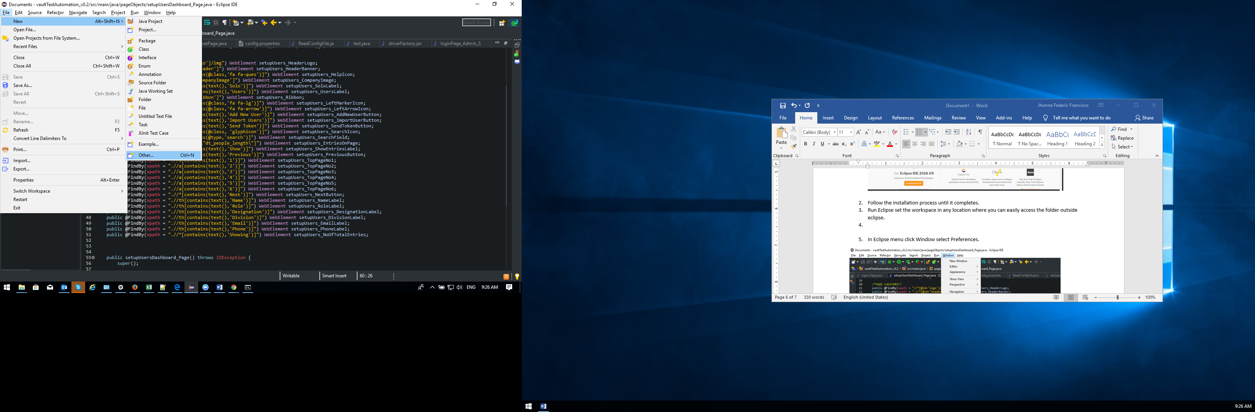

1. Select Maven Project, click Next

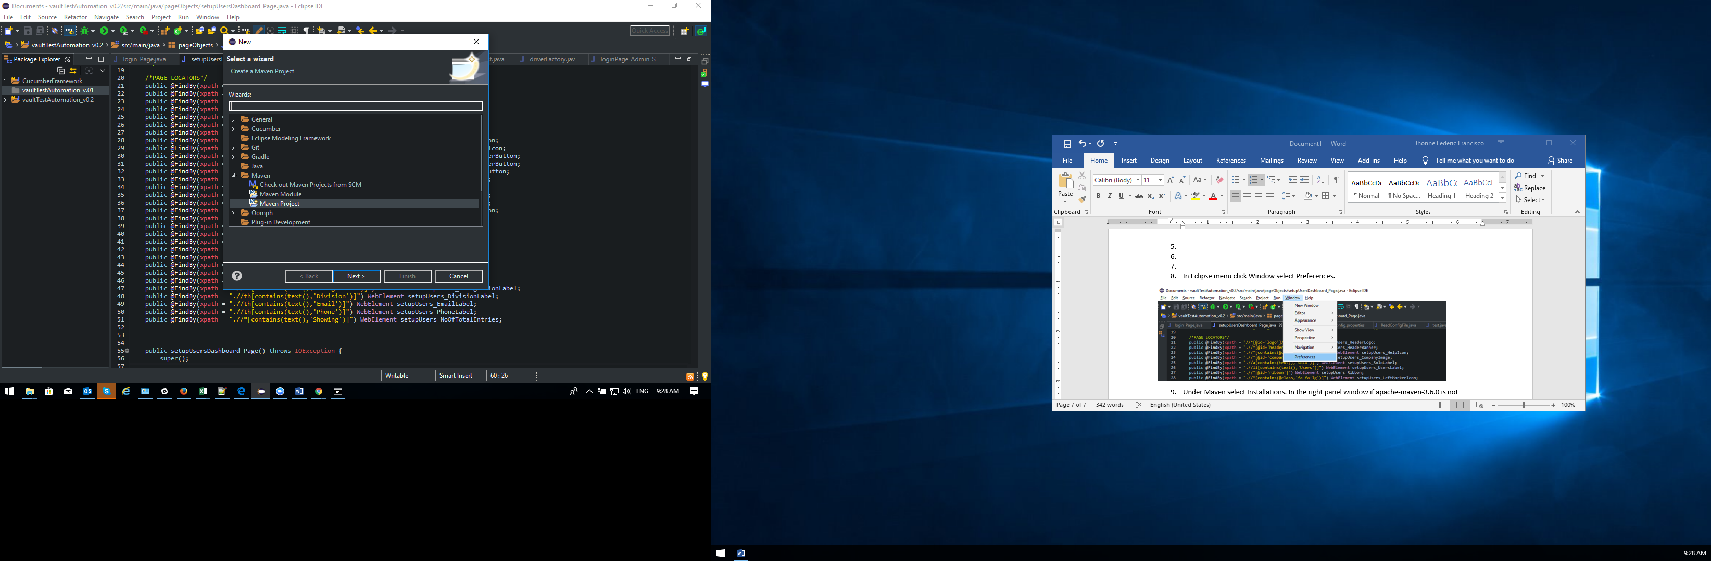

1. Select Use default Workspace location, indicate a folder location you prefer for this project.

Click Next.

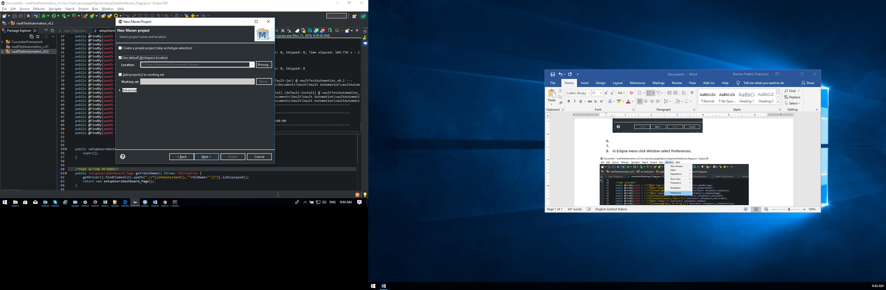

1. Click Next

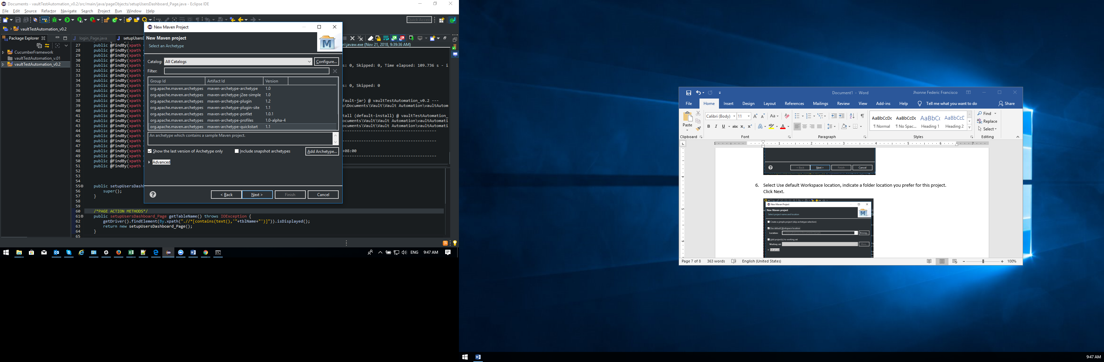

1. Enter Group Id, normally this indicates the web site we are to automate ie., Vault.com

But it is set in reverse as com.vault

Enter Artifact Id or project name – vaultTestAutomation

For the package just remove com.vault.

Then click Finish.

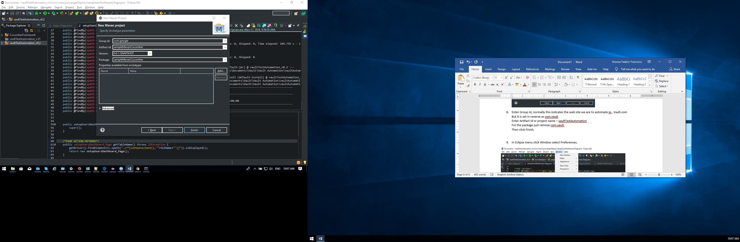

1. As we can see the project has been created on the left panel. But notice there is a warning marked under the folder.

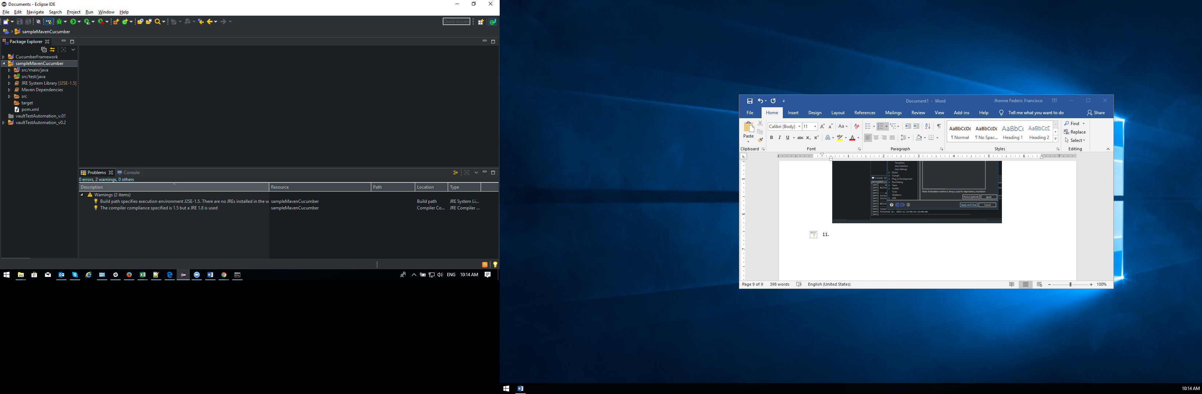

1. To remove the warning icon, we need to set some items. Click Window select Preferences.

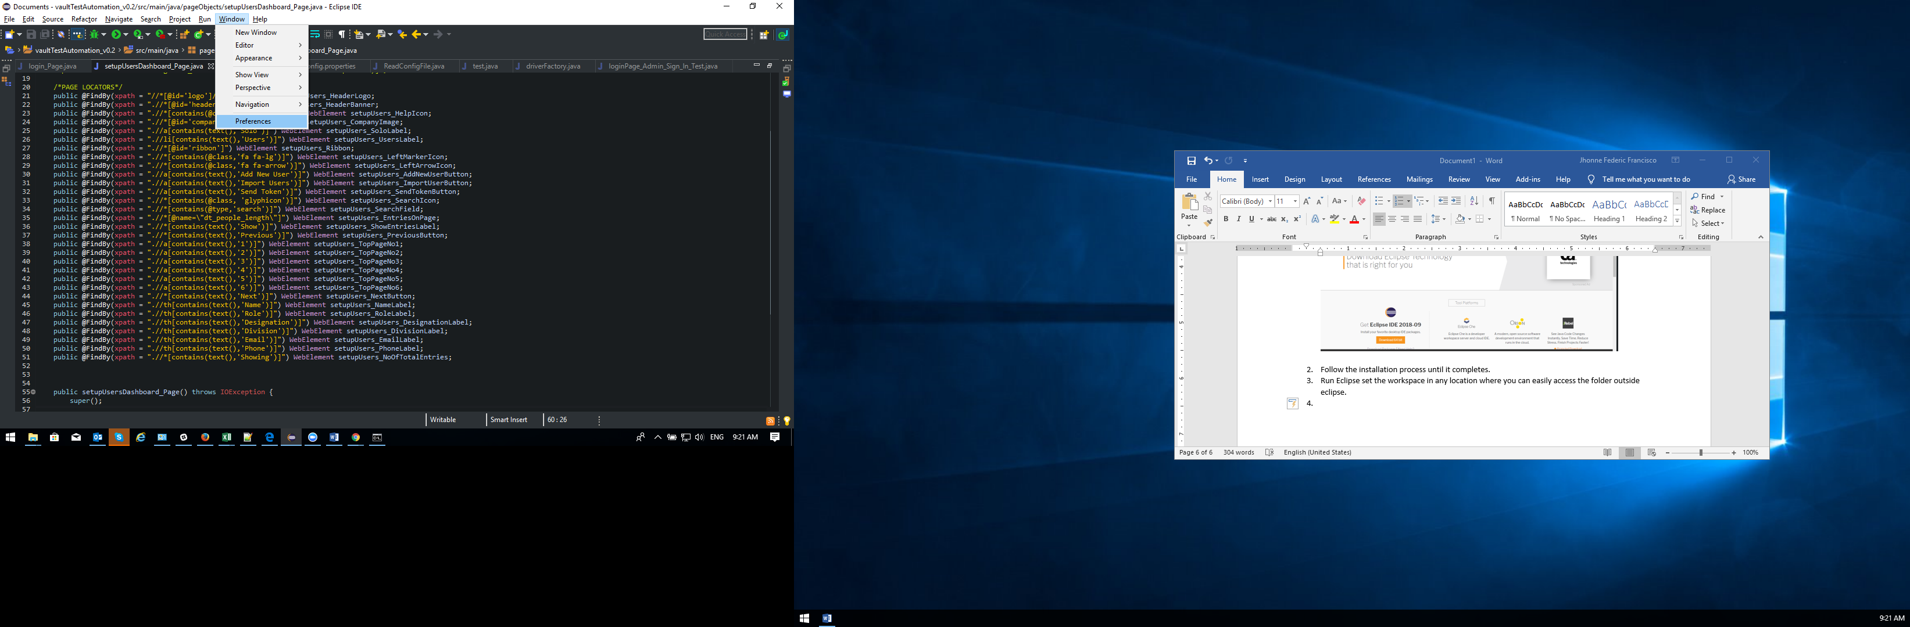

1. Under Maven select Installations. In the right panel window check apache-maven-3.6.

If apache-maven is not present click Add and then click Directory to map the maven folder.

Click finish and then apply.

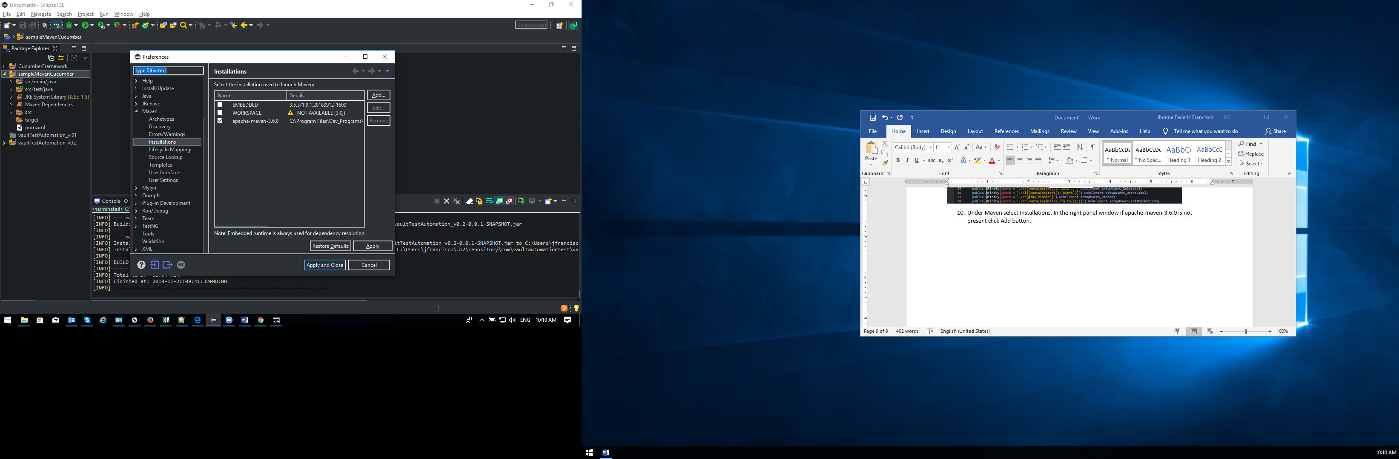

1. Under Java, select Installed JREs and Click Add

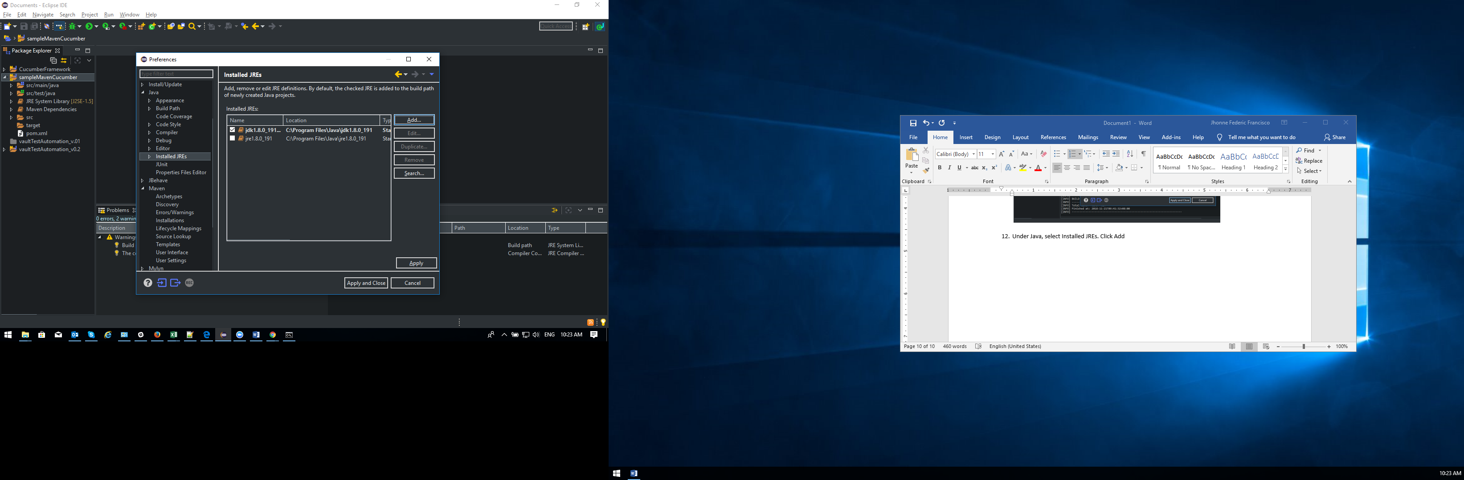

1. Select Standard VM click Next

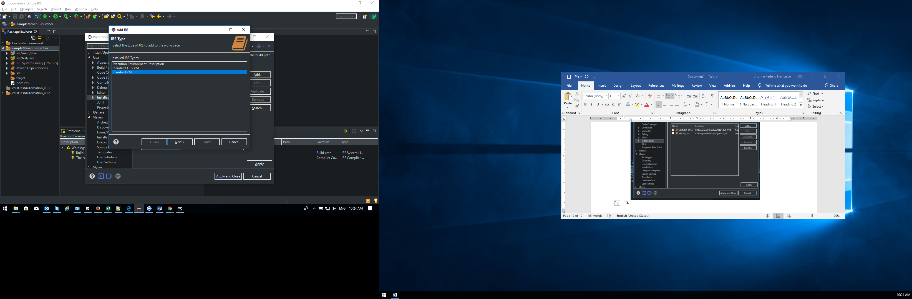

1. Click Directory and map the Java jdk folder.

In the Default VM arguments enter this variable

“-Dmaven.multiModuleProjectDirectory=M2_HOME”, remove the quotes

Click Finish then ensure to check the jdk we added and not the jre. Click Apply.

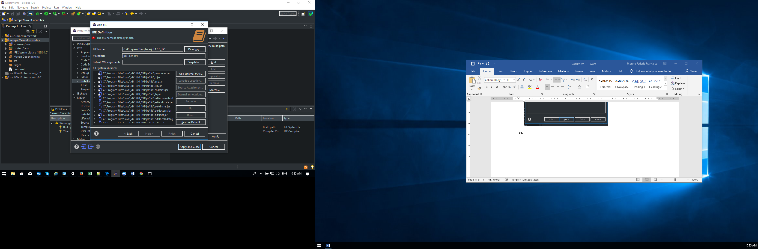

1. Now right click on the project select properties > Java Build Path

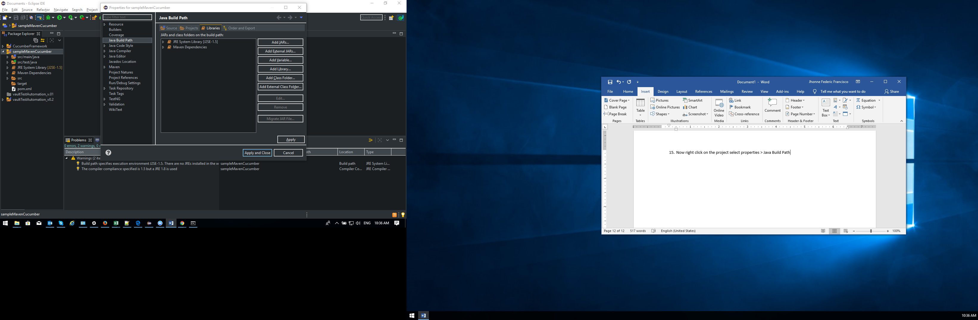

1. Click JRE System Library [J2SE-1.5], notice it is set to 1.5 when we installed 1.8.

Select Alternate JRE, in the dropdown list select jdk1.8.0_191. Then click Finish and Apply.

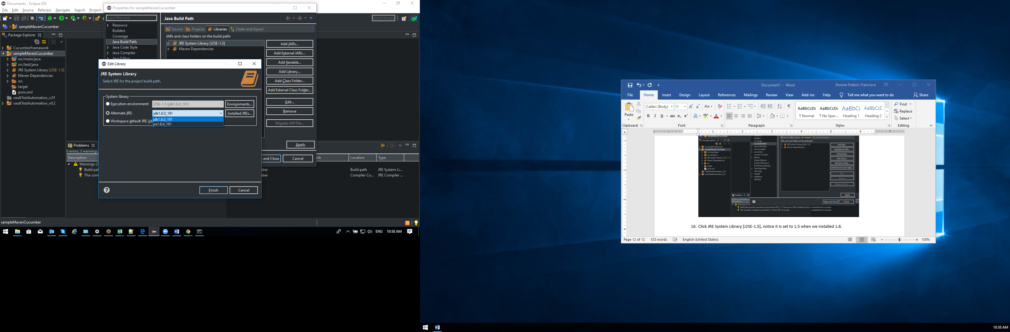

1. Click Add Variable, Select M2_REPO – C:\Users\*\.m2\reporsitory and Click OK. Click Apply and Close. If this is not visible click Configure Variables > New , then map the repository and named it as M2_REPO.

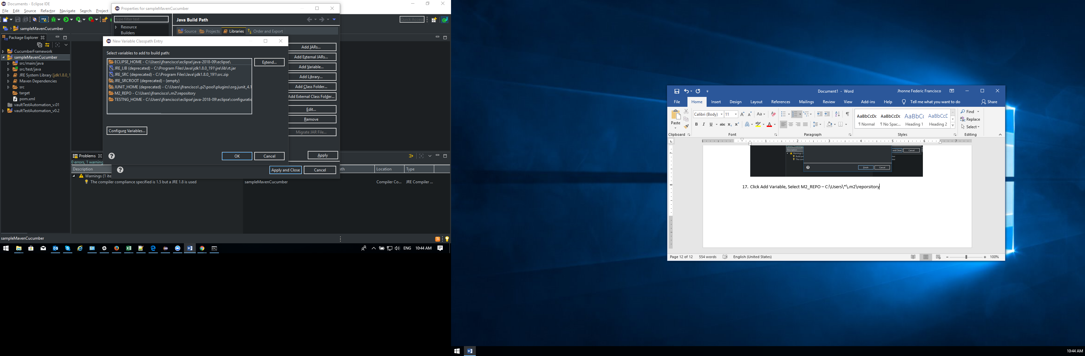

1. Now select pom file, right click select run then select and click Maven Install.

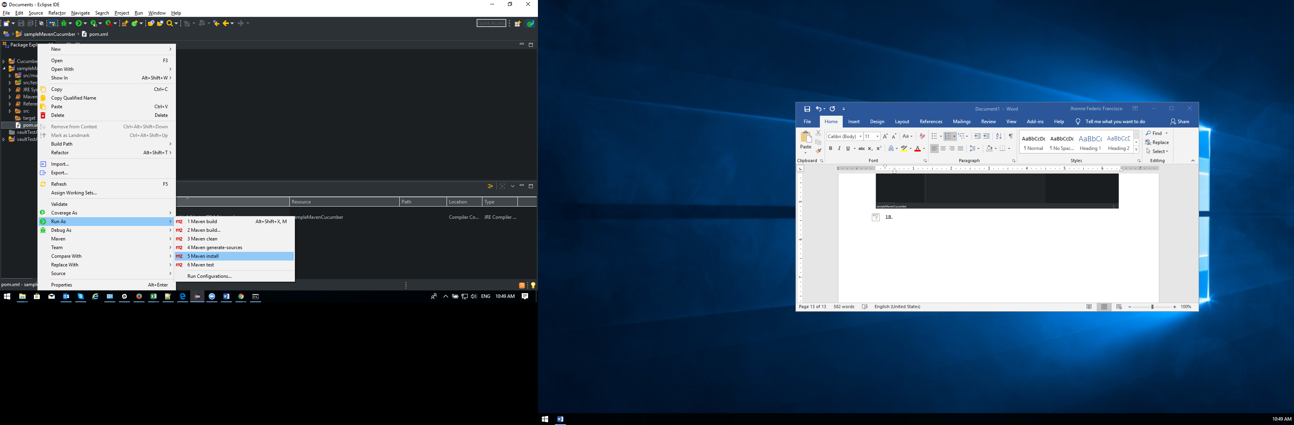

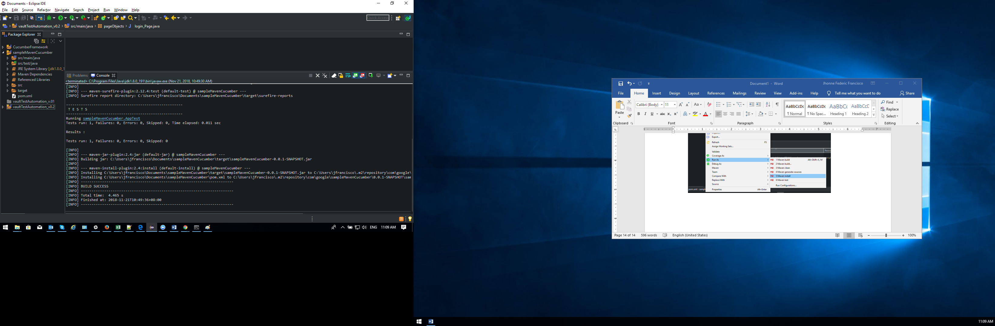

1. Double click on pom.xml, copy the xml code from the attach pom addins.txt file.

Paste it in the projects pom file overwriting from <build> to </dependencies>



1. To install TestNG, click Help menu>Eclipse Marketplace. In the Search tab type in TestNG and click Go. Click install to install TestNG. After the installation eclipse will restart.

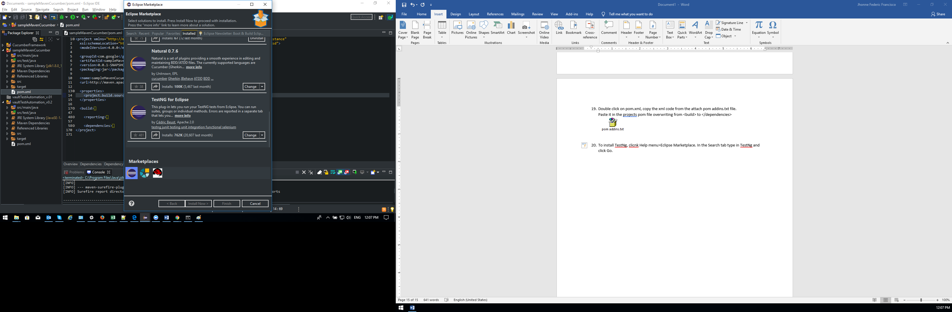

1. To install cucumber, in Search tab type in cucumber in find field and click Go. Natural 0.7.6 is displayed click install.

After the installation and restart, go back to eclipse.

Click Help > Install New Software copy this link - <https://cucumber.io/cucumber-eclipse/update-site> then paste it to the ‘Work with: ‘ field and click Next, when acknowledgement appeared click accept and finish. If a pop up appeared just click Ok.